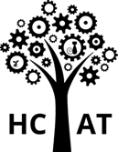


Art Curriculum

Purpose of study
Art, craft and design embody some of the highest forms of human creativity. A high-quality art and design education should engage, inspire and challenge pupils, equipping them with the knowledge and skills to experiment, invent and create their own works of art, craft and design. As pupils progress, they should be able to think critically and develop a more rigorous understanding of art and design. They should also know how art and design both reflect and shape our history, and contribute to the culture, creativity and wealth of our nation.

Aims
The National Curriculum for art and design aims to ensure that all pupils: • Produce creative work, exploring their ideas and recording their experiences • Become proficient in drawing, painting, sculpture and other art, craft and design techniques • Evaluate and analyse creative works using the language of art, craft and design • Know about great artists, craft makers and designers, and understand the historical and cultural development of their art forms.

Subject content
Key stage 1
Pupils should be taught:
• To use a range of materials creatively to design and make products
• To use drawing, painting and sculpture to develop and share their ideas, experiences and imagination
• To develop a wide range of art and design techniques in using colour, pattern, texture, line, shape, form and space
• About the work of a range of artists, craft makers and designers, describing the differences and similarities between different practices and disciplines, and making links to their own work.

Key stage 2
Pupils should be taught to develop their techniques, including their control and their use of materials, with creativity, experimentation and an increasing awareness of different kinds of art, craft and design. Pupils should be taught:
• To create sketch books to record their observations and use them to review and revisit ideas
• To improve their mastery of art and design techniques, including drawing, painting and sculpture with a range of materials [for example, pencil, charcoal, paint, clay]
• About great artists, architects and designers in history.

Art & Design Disciplines
At HCAT, we have identified the key disciplines within the Art & Design Curriculum as: All Media, Painting, 3D Sculpture and Drawing. These disciplines have been mapped out throughout our curriculum to ensure that there is progression between the key stages in which they are taught. The curricular content under the ‘All Media’ strand is not discipline specific and can be applied to Painting, 3D Sculpture or Drawing as these objectives are based upon reflection and peer evaluation. The disciplines of painting, 3D sculpture, and drawing have been mapped out throughout KS1 and KS2 to ensure that there is progression between key stages, painting is taught in cycle 1 and 3D sculpture is taught in cycle 2. There are opportunities for children to draw within the disciplines of painting and 3d sculpture, however we recognise that there are specific objectives which will need teaching in relation to drawing, therefore we begin by studying drawing in the Autumn term each year.

HCAT Art & Design Disciplines

Autumn | Spring | Summer
Drawing  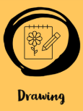 | Painting / Printing   | 3D Sculpture  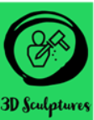

Upperwood Art Curriculum Concepts
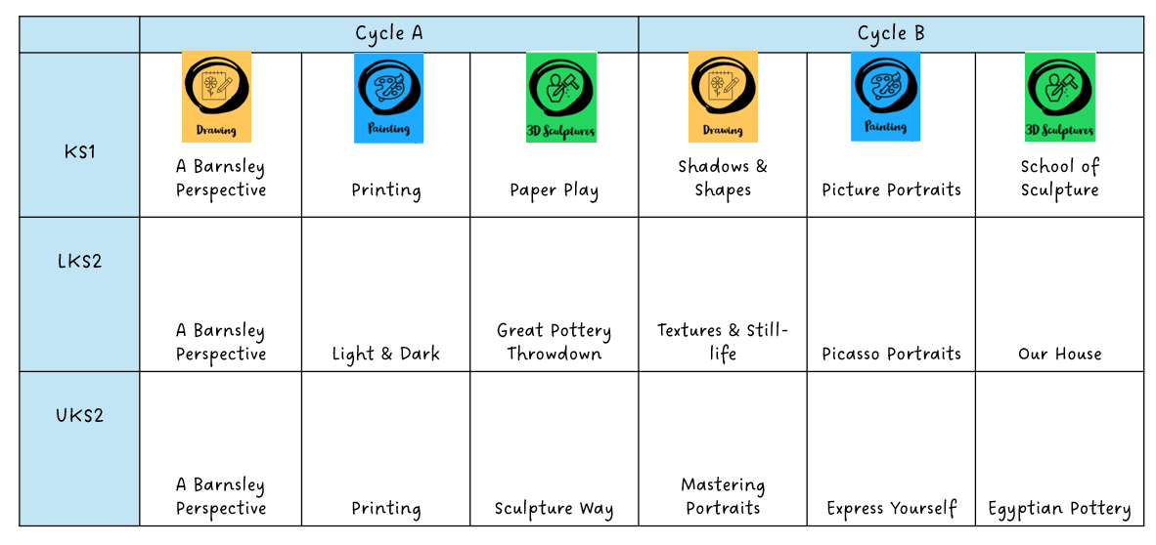
Art Deco House
It Figures!

